PDF-Based Knowledge Base RAG System
Participant Download, Project Execution & Submission Guidelines
Participant workflow: Open GitHub repository → Problem folder → Download project files → Open the participant notebook in Google Colab → Complete Tasks 1–5 → Save your work → Open SUBMISSION_INSTRUCTIONS.docx → Use the submission link → Upload your completed submission.

1. What You Need to Do
This is a guided project. Download the supplied project files from the GitHub repository, open the participant notebook in Google Colab, complete the five tasks in order, test your implementation, and submit your completed work using the submission instructions provided in the repository.

2. GitHub Repository Structure

GitHub - Ashutosh-UNext/Prodapt-AgenticAI
The repository contains two main folders:
Folder | Purpose
Problem | Contains the project/problem files that students must download and use.
Submissions | Contains the submission instructions. Open SUBMISSION_INSTRUCTIONS.docx to access the submission process/link.

3. How to Download the Project Files
- Open the GitHub repository link shared by your trainer/SME.
- On the repository home page, locate the Problem and Submissions folders.
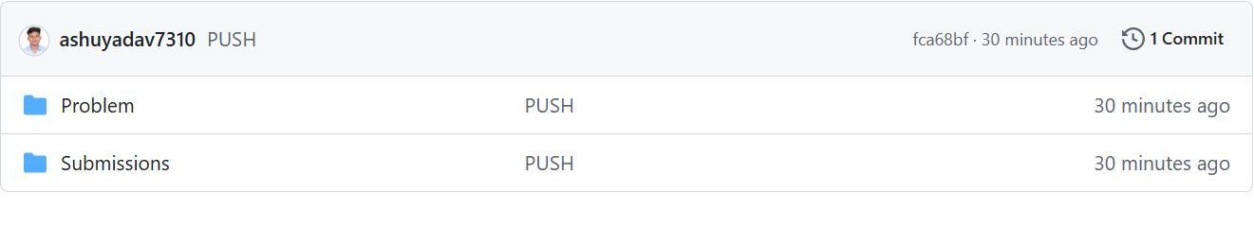
Figure 1. Repository home page showing the Problem and Submissions folders.
- Open the Problem folder.
- Download the participant problem notebook and the supporting project files provided there.
- For a notebook file, open the file page in GitHub and use the available download/raw option.
- If you prefer to download everything together, use the repository's Code → Download ZIP option, extract the ZIP, and work with the files inside the Problem folder.
Recommended: download the complete project files first so that the relative folder paths used by the notebook remain available.

4. Files You Are Expected to Download
- Participant problem notebook (for example, Participant_Problem.ipynb).
- The supplied PDF knowledge-base document.
- Any supporting dataset/reference files supplied under the Problem folder.
- Any templates or supporting files explicitly mentioned by the project instructions.

5. Open the Project in Google Colab
- Extract the downloaded repository ZIP if you used Download ZIP.
- Open Google Colab in your web browser.
- Navigate to the extracted project folder.
- Open the participant notebook, such as Participant_Problem.ipynb.
- Run the notebook from the beginning and complete the TODO sections.
- Save the notebook regularly.

6. Complete the Five Guided Tasks
Complete the tasks in order. Do not skip the earlier tasks because each task builds the RAG pipeline step-by-step.
Task | Focus | Expected Outcome
Task 1 | PDF Loading & Document Processing | PDF is loaded using LangChain and document/page information is available.
Task 2 | Text Chunking | Fixed-size document chunks are created with the required/configurable overlap.
Task 3 | Embeddings & ChromaDB | Document chunks are embedded and stored in ChromaDB.
Task 4 | Retrieval & RAG Answer Generation | Relevant chunks are retrieved and used with GPT-4o-mini to answer questions.
Task 5 | Final PDF RAG Application (app.py) | A complete user-facing RAG application is created with PDF input and question answering.

7. API Usage
The project uses the OpenAI API for embeddings and answer generation. Do not enter, hard-code, or share an API key in the notebook, source code, screenshots, or submission.
- Task 3 uses text-embedding-3-small.
- Task 4 uses GPT-4o-mini.
- Task 5 uses the same OpenAI components in the final RAG application.

8. Before You Submit – Validation Checklist
- PDF loading works successfully.
- Text chunking works successfully.
- The required embedding model is used.
- ChromaDB storage and retrieval work.
- Relevant chunks are retrieved for questions.
- GPT-4o-mini generates the answer using retrieved context.
- At least one question whose answer exists in the PDF has been tested.
- An out-of-context question has been tested.
- The final application/source files are included if created as part of the project.
- The completed notebook is saved.

9. Prepare Your Submission Files
Create a clean folder containing only the files needed for evaluation.
FirstName_LastName_PDF_RAG_Submission/
│
├── FirstName_LastName_Rag.ipynb
├── app.py (Task 5)
├── supporting_files/
Compress the folder into a ZIP file:
FirstName_LastName_PDF_RAG_Submission.zip

10. Do NOT Include These Files
- venv or .venv folders.
- __pycache__ folders.
- .ipynb_checkpoints folders.
- Temporary/cache files.
- API keys, passwords, tokens, or secret configuration values.
- Unrelated personal or system files.

11. How to Access the Submission Instructions
Use the Submissions folder in the GitHub repository. The repository currently contains SUBMISSION_INSTRUCTIONS.docx, which provides the submission process and submission link.
- Return to the repository home page.
- Open the Submissions folder.
- Open SUBMISSION_INSTRUCTIONS.docx.
- Read the instructions and locate the submission link.
- Open the provided submission link.
- Upload your completed submission in the required format (zip file).
- Submit the form/upload.
- Verify that your submission was successfully recorded.
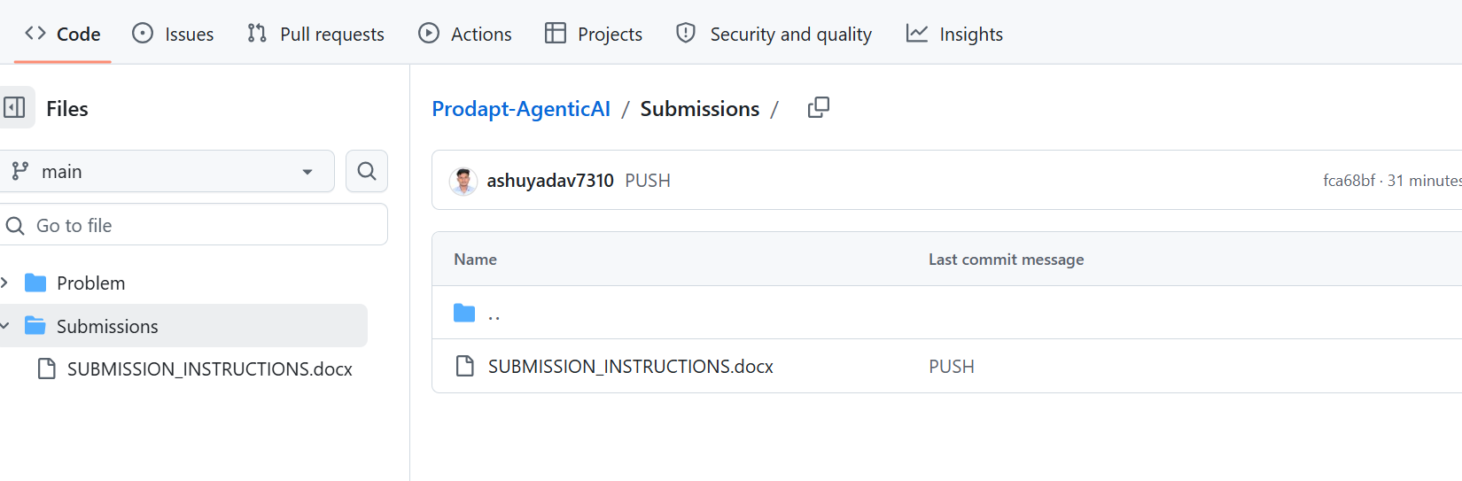
Figure 2. Submissions folder containing SUBMISSION_INSTRUCTIONS.docx.

12. Important: Do Not Upload Directly to GitHub Unless Instructed
Important: The GitHub repository is being used to distribute the problem/project files and submission instructions. Use the submission link provided in SUBMISSION_INSTRUCTIONS.docx unless your trainer explicitly tells you to use a different workflow.

13. Recommended Submission Naming
- FirstName_LastName_PDF_RAG_Submission.zip

14. Final Submission Checklist
☐ I downloaded the required project files from the Problem folder.
☐ I opened the participant notebook in Google Colab.
☐ I completed Tasks 1–5.
☐ I saved my completed notebook.
☐ I included the required source/application files.
☐ I tested the RAG question-answering flow.
☐ I removed any API key or secret.
☐ I created the final ZIP submission.
☐ I opened Submissions → SUBMISSION_INSTRUCTIONS.docx.
☐ I used the provided submission link.
☐ I verified that the submission was successful.

15. End-to-End Workflow
GitHub Repository
↓
Problem Folder
↓
Download Project Files
↓
Open Google Colab
↓
Complete Tasks 1–5
↓
Save Notebook + Supporting Files
↓
Create ZIP Submission
↓
Submissions Folder
↓
Open SUBMISSION_INSTRUCTIONS.docx
↓
Open Submission Link
↓
Upload Required Submission
↓
Submit and Verify
If you cannot access the repository, download the project files, or access the submission link, contact the trainer before the submission deadline.

